Practical: 4 | Implementation and Time analysis of factorial program using iterative and recursive method
18/08/2026

Aim: To Implement and Time analysis of factorial program using iterative and recursive method.

Algorithm:

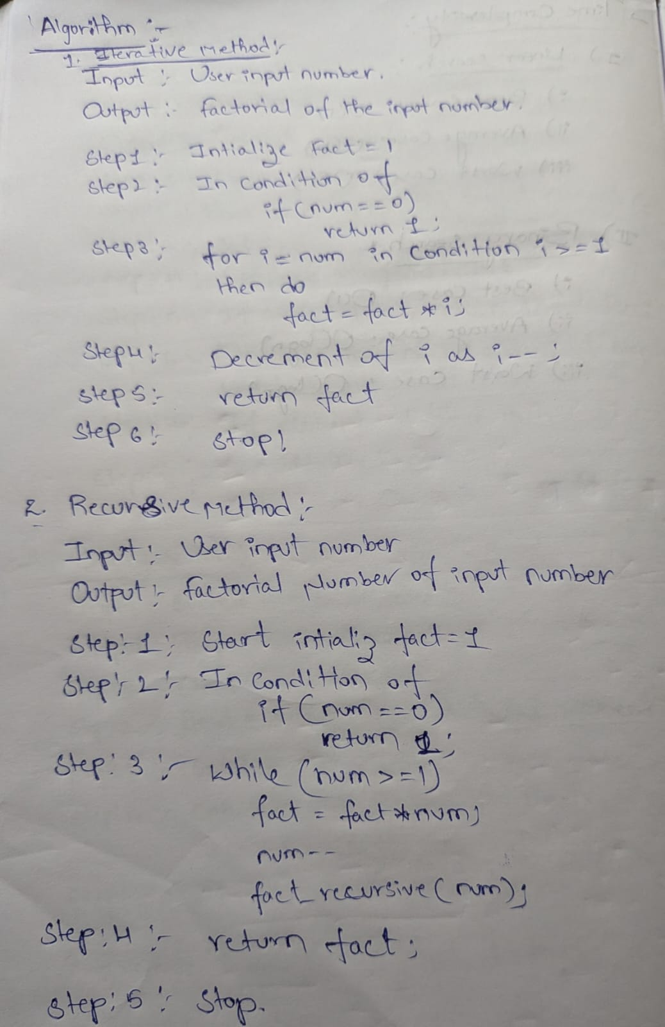

Program:

factorial program using iterative and recursive method

#include<iostream>
using namespace std;

int fact_iterative(int num){
int fact = 1;
if(num == 0)
return 1;
for(int i=num; i>=1; i--){
fact = fact*i;
}
return fact;
}

int fact_recursive(int num){
int fact = 1;
if(num == 0)
return 1;
while(num >= 1){
fact = fact*num;
num--;
fact_recursive(num);
}
return fact;
}

int main(){
cout<<"----------------Factorical-----------------------"<<endl;
int n;
cout<<"Enter your number: ";
cin>>n;
int i = fact_iterative(n);

cout<<"Iterative method:"<<endl;
cout<<n<<" factorical is "<<i;
cout<<endl<<endl;
int r = fact_recursive(n);
cout<<"Recursive method:"<<endl;
cout<<n<<" factorical is "<<r;

return 0;
}

Output:

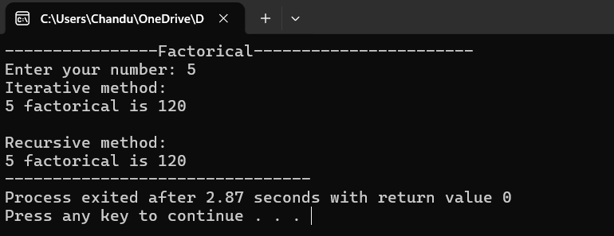

Time Complexity:

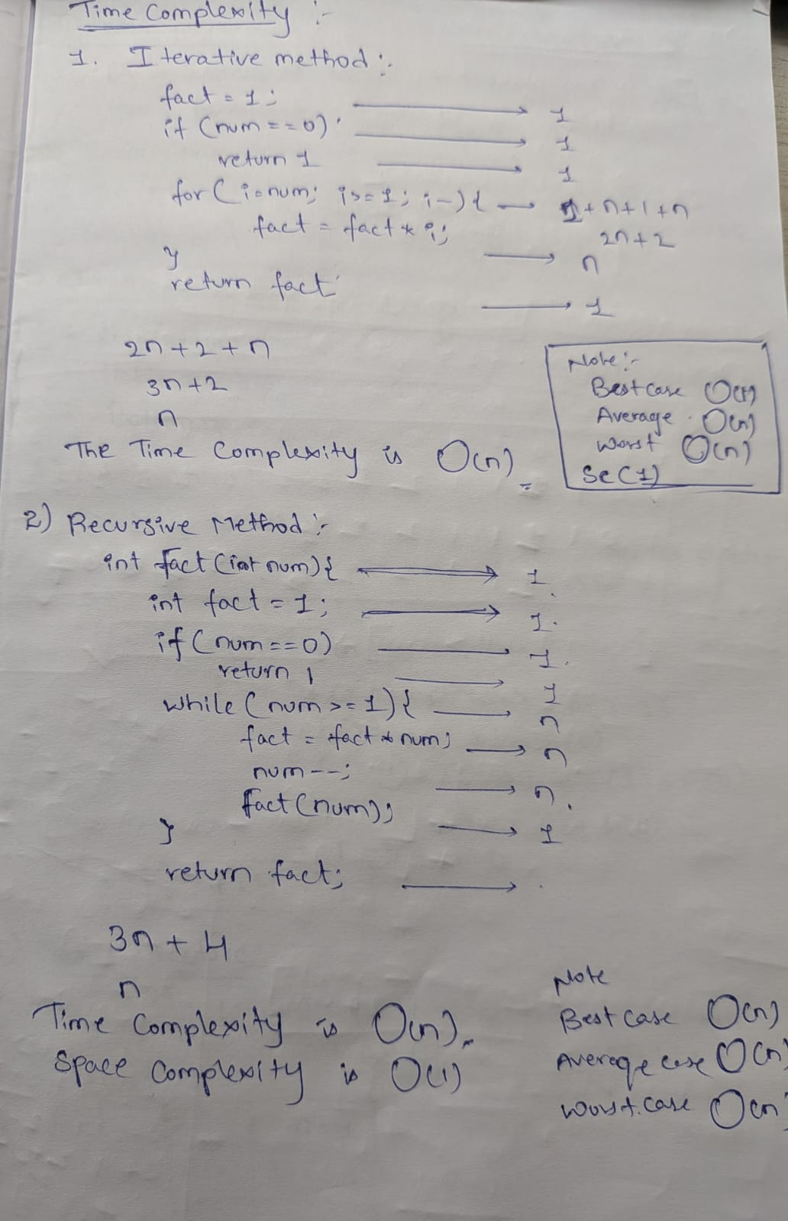

Conclusion:
The implementation of this program and the execution is successfully got executed and the time complexity in the Three cases are O(n) in the both Iterative, recursive methods And
Space complexity of both methods are O(1).

